Appendix A. Supplementary information

**Table S1.** Response (RE) and explanatory (EX) variables used in this study’s statistical analyses. Variables listed in the “Topography” category were also used in the sampling procedure to stratify inventory plots.

| Type | Category | Variable | Description | Units | Source |
| --- | --- | --- | --- | --- | --- |
| RE | Forest structure | Total number density | Total number of ITC objects per grid cell | stems ha–1 | This study (derived from NEON LiDAR) |
| RE | Forest structure | QMD | Quadratic mean of stem diameters of objects per grid cell | cm | This study (derived from NEON LiDAR) |
| RE | Forest structure | Basal area | Sum of cross-sectional areas of stems per hectare | m2 ha–1 | This study (derived from NEON LiDAR) |
| RE | Forest structure | 90th percentile height | Estimated maximum canopy height per grid cell | m | This study (derived from NEON LiDAR) |
| RE | Forest structure | Height skew | Third moment of height distribution per grid cell | NA | This study (derived from NEON LiDAR) |
| EX | Topography | Curvature | McNab’s (1993) index of terrain concavity/convexity computed in a 30x30 m window | unitless index | This study (derived from NEON LiDAR) |
| EX | Topography | Elevation | Elevation above sea level |  | This study (derived from NEON LiDAR) |
| EX | Topography | Slope | atan(√[(dz/dx)2+(dz/dy)2] computed in a 30x30 m window | degrees | This study (derived from NEON LiDAR) |
| EX | Topography | Folded aspect | Index of cardinal aspect adjusted for higher incident radiation on SW slopes | unitless index | This study (derived from NEON LiDAR) |
| EX | Topography | Heat load | Potential heat load calculated according to Eq. 3 in McCune and Keon (2002) | unitless index | This study (derived from NEON LiDAR) |
| EX | Topography | TPI | Topographic Position Index: Index of hillslope position computed in a 1000x1000 m window | unitless index | This study (derived from NEON LiDAR) |
| EX | Topography | TWI | Topographic Wetness Index: Terrain-driven ratio of upslope water supply to local drainage expressed as a function of local slope and upslope contributing area per unit contour length, computed on a 100 m pixel scale | unitless index | This study (derived from NEON LiDAR) |
| EX | Climate | AET | Actual evapotranspiration: mean annual water depth evaporated from the surface or transpired by plants per grid cell | mm | BCM (Budo et al. 2017) |
| EX | Climate | CWD | Climatic water deficit: difference between potential evapotranspiration (PET) and AET | where PET is the total depth of water that can be evaporated or transpired given prevailing atmospheric conditions | mm |
| BCM (Budo et al. 2017) |  |  |  |  |  |
| EX | Climate | SWE | Snow water equivalent derived by forcing iSnobal with 50 m snow depth data from eight Airborne Snow Observatory flights | mm | ASO |
| EX | Climate | ∆SWE | Relative velocity of snow disappearance; difference between winter SWE and summer SWE divided by days between flights averaged over three flight-years | mm | ASO |
| EX | Soil | AWC | Available water capacity: depth of plant-available water that can be stored per unit of soil depth | mm | SSURGO |
| EX | Soil | CEC | Total negative charge in soil at pH 7.0 | meq hg–1 | SSURGO |
| EX | Soil | ksat | Saturated hydraulic conductivity | µm sec–1 | SSURGO |
| EX | Soil | OM | Mass percentage of decomposed plant and animal material in the < 2 mm soil fraction | % mass | SSURGO |
| EX | Soil | pH | Potential of hydrogen in soil | -log[10] H+ | SSURGO |
| EX | Soil | Silt content | Mass percent of mineral particles 0.002 to 0.05mm in equivalent diameter in the < 2 mm soil fraction | % mass | SSURGO |
| EX | Geology | Lithologic substrate | Geological unit code | NA | Colorado Geological Survey |

**Table S2.** Measurements taken in field inventory with their units and a summary of methods.

| Measurement | Units | Method |
| --- | --- | --- |
| Species | NA | Visual identification |
| Stem height | m | Nikon Forestry Pro II hypsometer or metric tape |
| DBH | cm | Diameter tape or calipers |
| Stem geolocation | decimal degrees | Trimble Geo 7X GNSS unit |
| Crown illumination | unitless index | Visual determination using Clark and Clark (1992) |
| Canopy position | unitless index | Visual determination |
| Life status | NA | Visual determination |
| Health status | NA | Visual inspection for infection, damage, decay, browning, or wilting |

**Table S3.** Algorithms, parameters, and vectors of values applied on those parameters in ITD training and validation.

| I | Algorithm | Parameter | Description | Tested values |
| --- | --- | --- | --- | --- |
| 1 | Li (2012) | dt1 | Threshold 1. Refer to p. 79 in Li et al. (2012) | 0.5, 1.0, 1.5, 2.0 |
|  |  | dt2 | Threshold 2. Refer to p. 79 in Li et al. (2012) | 0.5, 1.0, 1.5, 2.0 |
|  |  | hmin | Minimum height threshold in m, below which a new tree cannot be initiated | 1.3 |
|  |  | R | Search radius. Refer to p. 79 in Li et al. (2012) | 0, 1, 2 |
|  |  | Zu | Height switch for dt1 and dt2. Use dt1 unless point height > Zu; then use dt2 | 14, 15, 16 |
| 2 | LMF-auto (Jean-Romain et al. in prep) | NA | LMF-auto is parameterless by design | NA |
| 3 | LMF fixed-window (Popescu and Wynne 2004) | ws | Window size: side length or diameter of the moving window used to detect the local maxima | The sequence 0.2:10.0 incrementing by 0.2 |
|  |  | shape | Shape of the window, either circular or square | circular, square |
|  |  | hmin | Minimum height threshold in m, below which a new tree cannot be initiated | 1.3 |
| 4 | LMF variable-window (Popescu and Wynne 2004) | b0 | First coefficient, β_0 on the function for computing variable-window size: w=β_0*-e^(-β_1 (Z-2)-1)+β_2 | 0.5, 1.0, 1.5, 2.0, 2.5 |
|  |  | b1 | Second coefficient β_1 on the variable window size function | 0.02, 0.04, 0.06, 0.08, 0.10, 0.12, 0.14, 0.16 |
|  |  | c0 | Third coefficient β_2 on the variable window size function | 1, 2, 3, 4, 5 |
|  |  | shape | Shape of the window, either circular or square | circular, square |
|  |  | hmin | Minimum height threshold in m, below which a new tree cannot be initiated | 1.3 |
| 5 | LayerStacking (Ayrey 2017) | start | the starting height above ground at which layer divisions begin | 0.5 |
|  |  | resolution | Resolution of the CHM | 0.5, 1 |
|  |  | window1 | window radius for the first local maximum filter for detecting tree tops | 1, 2, 3 |
|  |  | buffer | size of the buffer enforced around each point to create a polygonal cluster | 1, 2, 3 |
|  |  | hardwood | logical switch, where False adds weight to clusters to account for mid-canopy density in conifer stands | F |
|  |  | window2 | window radius for the second local maximum filter for detecting tree tops | 0.2, 0.4, 0.6, 0.8 |
|  |  | hmin | Minimum height threshold in m, below which a new tree cannot be initiated | 1.3 |
| 6 | MultiCHM (Eysn 2015) | resolution | Resolution of the CHM | 0.5, 1 |
|  |  | layer_thickness | The eliminating layer in the original paper is defined as a layer of layer_thickness m below the current CHM. Refer to Eysn 2015 p. 1728). | 0.25, 0.5 |
|  |  | dist_2d | 2D threshold for delineating a tree from local maximum. A tree is created if no other detected tree lies within this distance | 0.1, 0.25, 0.5, 1, 2 |
|  |  | dist_3d | 3D threshold for delineating a tree from local maximum. A tree is created if no other detected tree lies within this distance | 0.5, 1, 3, 5 |
| 7 | PTrees (Vega 2014) | k | Number of nearest neighbors to use in search. Refer to Vega (2014). | All forward and reverse permutations of the sequence: {5, 6, 7, 8, 10, 12, 15, 20, 25, 30, 40, 60, 80, 100} |
|  |  | hmin | Minimum height of a detected tree. Addition not in the original paper included to reduce oversegmentation. | 1.3 |
| 8 | Inverted watershed (Koch et al. 2006) | resolution | Resolution of the CHM | 0.5, 1, 1.5, 2 |
|  |  | th_tree | Minimum height threshold in m, below which a new tree cannot be initiated | 1.3 |
|  |  | subcircle_size | radius of circles used to rasterize the point cloud to CHM | 0.1, 0.2, 0.3, 0.4, 0.5, 0.6, 0.7, 0.8 |
|  |  | kernel_size | Size of kernel to smoothe CHM before applying watershed algorithm | 3, 5, 9, 15 |
|  |  | tolerance | Minimum Z distance between a tree candidate’s highest point and the point where it contacts another tree. If Z distance < tolerance, the object is merged with its highest neighbor. | 1 |
|  |  | ext | Search radius in pixels for neighboring trees | 1 |

**Table S4.** Tree height (∆Z) and horizontal (∆XY) distance criteria for candidate searching in the matching procedure (Eysn et al. 2015).

| Tree height (Z) | ∆Z criterion | ∆Y criterion |
| --- | --- | --- |
| Z ≤ 10 m | ∆Z < 3 m | ∆XY < 3 m |
| 10 m < Z ≤ 15 m | ∆Z < 3 m | ∆XY < 4 m |
| 15 m < Z ≤ 25 m | ∆Z < 4 m | ∆XY < 5 m |
| Z > 25 m | ∆Z < 4 m | ∆XY < 5 m |

**Table S5.** Performance statistics for each parameter permutation used to force the LayerStacking individual tree detection (ITD) algorithm.

| Parameter set | N reference trees | N detected trees | Extraction rate | Match rate | Overall accuracy | Omission rate | Commission rate | RMS ∆XY | RMS ∆Z | RMS ∆XYZ | Precision | Recall | F |
| --- | --- | --- | --- | --- | --- | --- | --- | --- | --- | --- | --- | --- | --- |
| 1 | 4,355 | 15,147 | 3.48 | 0.71 | 0.71 | 0.34 | 0.81 | 1.95 | 1.11 | 2.25 | 0.19 | 0.71 | 0.29 |
| 2 | 4,355 | 11,253 | 2.58 | 0.70 | 0.70 | 0.34 | 0.75 | 2.07 | 1.22 | 2.40 | 0.26 | 0.70 | 0.36 |
| 3 | 4,355 | 14,958 | 3.43 | 0.71 | 0.71 | 0.33 | 0.81 | 1.97 | 1.13 | 2.27 | 0.20 | 0.71 | 0.30 |
| 4 | 4,355 | 11,290 | 2.59 | 0.70 | 0.70 | 0.33 | 0.75 | 2.09 | 1.23 | 2.42 | 0.26 | 0.70 | 0.36 |
| 5 | 4,355 | 15,046 | 3.45 | 0.71 | 0.71 | 0.33 | 0.81 | 1.93 | 1.13 | 2.24 | 0.20 | 0.71 | 0.30 |
| 6 | 4,355 | 11,047 | 2.54 | 0.69 | 0.69 | 0.35 | 0.75 | 2.08 | 1.20 | 2.40 | 0.26 | 0.69 | 0.36 |
| 7 | 4,355 | 4,196 | 0.96 | 0.55 | 0.55 | 0.49 | 0.51 | 2.45 | 1.46 | 2.85 | 0.53 | 0.55 | 0.51 |
| 8 | 4,355 | 3,858 | 0.89 | 0.52 | 0.52 | 0.50 | 0.48 | 2.51 | 1.45 | 2.90 | 0.55 | 0.52 | 0.51 |
| 9 | 4,355 | 4,186 | 0.96 | 0.54 | 0.54 | 0.49 | 0.51 | 2.50 | 1.44 | 2.88 | 0.52 | 0.54 | 0.50 |
| 10 | 4,355 | 3,830 | 0.88 | 0.52 | 0.52 | 0.51 | 0.48 | 2.54 | 1.44 | 2.92 | 0.55 | 0.52 | 0.51 |
| 11 | 4,355 | 4,153 | 0.95 | 0.54 | 0.54 | 0.49 | 0.51 | 2.49 | 1.44 | 2.88 | 0.52 | 0.54 | 0.50 |
| 12 | 4,355 | 3,848 | 0.88 | 0.51 | 0.51 | 0.51 | 0.49 | 2.53 | 1.43 | 2.90 | 0.54 | 0.51 | 0.50 |
| 13 | 4,355 | 1,991 | 0.46 | 0.34 | 0.34 | 0.67 | 0.36 | 2.67 | 1.45 | 3.04 | 0.70 | 0.34 | 0.44 |
| 14 | 4,355 | 1,845 | 0.42 | 0.32 | 0.32 | 0.70 | 0.37 | 2.72 | 1.46 | 3.08 | 0.69 | 0.32 | 0.41 |
| 15 | 4,355 | 1,996 | 0.46 | 0.33 | 0.33 | 0.68 | 0.38 | 2.66 | 1.47 | 3.04 | 0.68 | 0.33 | 0.43 |
| 16 | 4,355 | 1,777 | 0.41 | 0.32 | 0.32 | 0.70 | 0.35 | 2.76 | 1.50 | 3.14 | 0.71 | 0.32 | 0.42 |
| 17 | 4,355 | 1,999 | 0.46 | 0.34 | 0.34 | 0.67 | 0.37 | 2.67 | 1.44 | 3.03 | 0.68 | 0.34 | 0.44 |
| 18 | 4,355 | 1,785 | 0.41 | 0.31 | 0.31 | 0.70 | 0.36 | 2.68 | 1.49 | 3.06 | 0.70 | 0.31 | 0.41 |
| 19 | 4,355 | 5,259 | 1.21 | 0.42 | 0.42 | 0.64 | 0.60 | 2.46 | 1.34 | 2.80 | 0.50 | 0.42 | 0.34 |
| 20 | 4,355 | 11,295 | 2.59 | 0.70 | 0.70 | 0.34 | 0.75 | 2.07 | 1.23 | 2.41 | 0.26 | 0.70 | 0.36 |
| 21 | 4,355 | 2,512 | 0.58 | 0.25 | 0.25 | 0.80 | 0.46 | 2.73 | 1.47 | 3.10 | 0.65 | 0.25 | 0.26 |
| 22 | 4,355 | 11,241 | 2.58 | 0.69 | 0.69 | 0.35 | 0.75 | 2.05 | 1.19 | 2.37 | 0.26 | 0.69 | 0.36 |
| 23 | 4,355 | 1,802 | 0.41 | 0.20 | 0.20 | 0.82 | 0.45 | 2.72 | 1.48 | 3.10 | 0.64 | 0.20 | 0.26 |
| 24 | 4,355 | 11,210 | 2.57 | 0.70 | 0.70 | 0.35 | 0.75 | 2.08 | 1.20 | 2.40 | 0.26 | 0.70 | 0.36 |
| 25 | 4,355 | 1,406 | 0.32 | 0.26 | 0.26 | 0.79 | 0.35 | 2.75 | 1.49 | 3.13 | 0.73 | 0.26 | 0.31 |
| 26 | 4,355 | 3,844 | 0.88 | 0.51 | 0.51 | 0.51 | 0.48 | 2.50 | 1.43 | 2.89 | 0.55 | 0.51 | 0.51 |
| 27 | 4,355 | 804 | 0.18 | 0.15 | 0.15 | 0.87 | 0.31 | 2.86 | 1.53 | 3.25 | 0.78 | 0.15 | 0.20 |
| 28 | 4,355 | 3,858 | 0.89 | 0.52 | 0.52 | 0.50 | 0.48 | 2.50 | 1.41 | 2.87 | 0.55 | 0.52 | 0.51 |
| 29 | 4,355 | 626 | 0.14 | 0.11 | 0.11 | 0.89 | 0.31 | 2.89 | 1.51 | 3.26 | 0.79 | 0.11 | 0.19 |
| 30 | 4,355 | 3,827 | 0.88 | 0.51 | 0.51 | 0.51 | 0.48 | 2.51 | 1.44 | 2.89 | 0.55 | 0.51 | 0.51 |
| 31 | 4,355 | 638 | 0.15 | 0.14 | 0.14 | 0.89 | 0.32 | 2.82 | 1.64 | 3.26 | 0.76 | 0.14 | 0.20 |
| 32 | 4,355 | 1,810 | 0.42 | 0.30 | 0.30 | 0.70 | 0.37 | 2.65 | 1.50 | 3.04 | 0.68 | 0.30 | 0.40 |
| 33 | 4,355 | 463 | 0.11 | 0.10 | 0.10 | 0.91 | 0.29 | 2.87 | 1.60 | 3.29 | 0.80 | 0.10 | 0.15 |
| 34 | 4,355 | 1,815 | 0.42 | 0.32 | 0.32 | 0.69 | 0.35 | 2.68 | 1.48 | 3.06 | 0.71 | 0.32 | 0.42 |
| 35 | 4,355 | 403 | 0.09 | 0.08 | 0.08 | 0.92 | 0.28 | 2.92 | 1.57 | 3.32 | 0.79 | 0.08 | 0.14 |
| 36 | 4,355 | 1,780 | 0.41 | 0.30 | 0.30 | 0.71 | 0.37 | 2.71 | 1.48 | 3.08 | 0.68 | 0.30 | 0.40 |
| 37 | 4,355 | 4,941 | 1.13 | 0.42 | 0.42 | 0.65 | 0.58 | 2.52 | 1.41 | 2.88 | 0.52 | 0.42 | 0.34 |
| 38 | 4,355 | 4,018 | 0.92 | 0.41 | 0.41 | 0.66 | 0.53 | 2.54 | 1.48 | 2.94 | 0.54 | 0.41 | 0.36 |
| 39 | 4,355 | 2,284 | 0.52 | 0.24 | 0.24 | 0.82 | 0.45 | 2.73 | 1.57 | 3.15 | 0.67 | 0.24 | 0.24 |
| 40 | 4,355 | 3,185 | 0.73 | 0.33 | 0.33 | 0.73 | 0.48 | 2.64 | 1.57 | 3.08 | 0.61 | 0.33 | 0.32 |
| 41 | 4,355 | 1,584 | 0.36 | 0.18 | 0.18 | 0.83 | 0.43 | 2.77 | 1.58 | 3.19 | 0.67 | 0.18 | 0.25 |
| 42 | 4,355 | 2,488 | 0.57 | 0.28 | 0.28 | 0.77 | 0.46 | 2.65 | 1.57 | 3.08 | 0.63 | 0.28 | 0.30 |
| 43 | 4,355 | 1,334 | 0.31 | 0.23 | 0.23 | 0.81 | 0.37 | 2.72 | 1.53 | 3.12 | 0.71 | 0.23 | 0.29 |
| 44 | 4,355 | 1,434 | 0.33 | 0.24 | 0.24 | 0.80 | 0.36 | 2.72 | 1.57 | 3.14 | 0.72 | 0.24 | 0.31 |
| 45 | 4,355 | 754 | 0.17 | 0.15 | 0.15 | 0.88 | 0.31 | 2.84 | 1.63 | 3.27 | 0.79 | 0.15 | 0.20 |
| 46 | 4,355 | 1,208 | 0.28 | 0.21 | 0.21 | 0.83 | 0.33 | 2.74 | 1.61 | 3.18 | 0.74 | 0.21 | 0.28 |
| 47 | 4,355 | 585 | 0.13 | 0.11 | 0.11 | 0.90 | 0.31 | 2.92 | 1.62 | 3.34 | 0.79 | 0.11 | 0.18 |
| 48 | 4,355 | 981 | 0.23 | 0.18 | 0.18 | 0.85 | 0.31 | 2.80 | 1.64 | 3.25 | 0.76 | 0.18 | 0.26 |
| 49 | 4,355 | 598 | 0.14 | 0.12 | 0.12 | 0.90 | 0.35 | 2.77 | 1.59 | 3.20 | 0.74 | 0.12 | 0.18 |
| 50 | 4,355 | 703 | 0.16 | 0.14 | 0.14 | 0.87 | 0.30 | 2.84 | 1.62 | 3.27 | 0.80 | 0.14 | 0.21 |
| 51 | 4,355 | 455 | 0.10 | 0.09 | 0.09 | 0.92 | 0.30 | 2.89 | 1.67 | 3.34 | 0.80 | 0.09 | 0.14 |
| 52 | 4,355 | 652 | 0.15 | 0.13 | 0.13 | 0.89 | 0.30 | 2.80 | 1.68 | 3.26 | 0.78 | 0.13 | 0.20 |
| 53 | 4,355 | 396 | 0.09 | 0.08 | 0.08 | 0.92 | 0.28 | 2.93 | 1.70 | 3.39 | 0.80 | 0.08 | 0.14 |
| 54 | 4,355 | 562 | 0.13 | 0.11 | 0.11 | 0.90 | 0.29 | 2.85 | 1.75 | 3.34 | 0.78 | 0.11 | 0.18 |
| 55 | 4,355 | 4,120 | 0.95 | 0.39 | 0.39 | 0.69 | 0.56 | 2.56 | 1.40 | 2.92 | 0.55 | 0.39 | 0.33 |
| 56 | 4,355 | 3,445 | 0.79 | 0.37 | 0.37 | 0.69 | 0.51 | 2.56 | 1.53 | 2.98 | 0.57 | 0.37 | 0.35 |
| 57 | 4,355 | 1,849 | 0.42 | 0.21 | 0.21 | 0.84 | 0.42 | 2.78 | 1.58 | 3.20 | 0.69 | 0.21 | 0.21 |
| 58 | 4,355 | 2,843 | 0.65 | 0.30 | 0.30 | 0.76 | 0.47 | 2.64 | 1.59 | 3.09 | 0.63 | 0.30 | 0.30 |
| 59 | 4,355 | 1,166 | 0.27 | 0.14 | 0.14 | 0.87 | 0.41 | 2.78 | 1.62 | 3.22 | 0.70 | 0.14 | 0.20 |
| 60 | 4,355 | 2,203 | 0.51 | 0.26 | 0.26 | 0.78 | 0.44 | 2.70 | 1.63 | 3.16 | 0.66 | 0.26 | 0.29 |
| 61 | 4,355 | 1,109 | 0.25 | 0.21 | 0.21 | 0.83 | 0.35 | 2.74 | 1.56 | 3.15 | 0.74 | 0.21 | 0.27 |
| 62 | 4,355 | 1,247 | 0.29 | 0.22 | 0.22 | 0.81 | 0.34 | 2.77 | 1.55 | 3.18 | 0.73 | 0.22 | 0.29 |
| 63 | 4,355 | 656 | 0.15 | 0.14 | 0.14 | 0.89 | 0.30 | 2.86 | 1.65 | 3.30 | 0.79 | 0.14 | 0.18 |
| 64 | 4,355 | 1,106 | 0.25 | 0.20 | 0.20 | 0.84 | 0.33 | 2.80 | 1.62 | 3.24 | 0.75 | 0.20 | 0.26 |
| 65 | 4,355 | 515 | 0.12 | 0.10 | 0.10 | 0.91 | 0.31 | 2.91 | 1.71 | 3.37 | 0.79 | 0.10 | 0.16 |
| 66 | 4,355 | 894 | 0.21 | 0.16 | 0.16 | 0.86 | 0.31 | 2.84 | 1.70 | 3.31 | 0.75 | 0.16 | 0.24 |
| 67 | 4,355 | 563 | 0.13 | 0.12 | 0.12 | 0.90 | 0.32 | 2.82 | 1.59 | 3.24 | 0.76 | 0.12 | 0.18 |
| 68 | 4,355 | 634 | 0.15 | 0.13 | 0.13 | 0.89 | 0.29 | 2.90 | 1.63 | 3.33 | 0.80 | 0.13 | 0.19 |
| 69 | 4,355 | 432 | 0.10 | 0.09 | 0.09 | 0.92 | 0.29 | 2.92 | 1.72 | 3.39 | 0.81 | 0.09 | 0.14 |
| 70 | 4,355 | 590 | 0.14 | 0.11 | 0.11 | 0.90 | 0.30 | 2.93 | 1.72 | 3.40 | 0.79 | 0.11 | 0.18 |
| 71 | 4,355 | 374 | 0.09 | 0.08 | 0.08 | 0.92 | 0.26 | 2.92 | 1.74 | 3.40 | 0.81 | 0.08 | 0.14 |
| 72 | 4,355 | 521 | 0.12 | 0.11 | 0.11 | 0.90 | 0.27 | 2.96 | 1.74 | 3.43 | 0.80 | 0.11 | 0.18 |

**Table S6.** User-specified parameters ($λ_{1:7}$) applied in the Layer Stacking algorithm with the optimal values found in training. The algorithm proceeds by first dividing the point cloud into stacked horizontal layers at 1-m intervals, starting at $λ_{1}$ m above ground. A series of clustering procedures is then applied to each layer. In the lowest three layers ( $λ_{1}+1:λ_{1}+3$ m a.g.), points are clustered through Density-Based Scanning [@ester_densitybased_1996]; points within these initial clusters are removed as non-tree low vegetation, while those lying outside clusters are retained as sparse returns from small tree boles. Next, a canopy height model (CHM) of resolution $λ_{2}$ is computed from the point cloud. Tree tops are identified from the CHM using a local maximum filter (LMF) with a window of radius $λ_{3}$. Then, points in each layer undergo *k*-means clustering, using the local maxima as seeds, and a polygonal buffer of radius $λ_{4}$ is placed around each resulting cluster. The polygons from each layer are then flattened and rasterized to create an intermediate “overlap map.” This abstraction quantifies the density of clusters, such that areas of high-density polygonal overlap represent individual trees. In conifer forests, this delineation can be improved with an additional parameter, $λ_{5}$, which enforces higher weighting for clusters near the canopy top, because these tend to be closer to a conifer’s center. A second LMF is applied to the overlap map, using a window of radius $λ_{6}$, and local maxima are taken to be tree centers. Additional smoothing of the local maxima, and filtering and merging of clusters, yields a set of points representing tree tops with embedded height and position information.

| ID | Parameter | Description | Optimal value |
| --- | --- | --- | --- |
| λ1 | start | Starting height above ground at which layer divisions begin | 0.5 |
| λ2 | resolution | Resolution of the CHM | 0.5 |
| λ3 | window1 | Window radius for the first local maximum filter for detecting tree tops | 1.2 |
| λ4 | buffer | Size of the buffer enforced around each point to create a polygonal cluster | 0.5 |
| λ5 | hardwood | Logical switch, where False adds weight to clusters to account for mid-canopy density in conifer stands | 0.0 |
| λ6 | window2 | Window radius for the second local maximum filter for detecting tree tops | 2.0 |
| λ7 | hmin | Minimum height threshold, below which a new tree cannot be initiated | 1.3 |

**Table S7.** Basis functions (Call), initial k (k’) and estimated degrees of freedom (edf) for each variable and 2-way interaction in GAMs. k’ and edf values are reported separately for each response variable.

| I | Algorithm | Parameter | Description | Tested values |
| --- | --- | --- | --- | --- |
| 1 | Li (2012) | dt1 | Threshold 1. Refer to p. 79 in Li et al. (2012) | 0.5, 1.0, 1.5, 2.0 |
|  |  | dt2 | Threshold 2. Refer to p. 79 in Li et al. (2012) | 0.5, 1.0, 1.5, 2.0 |
|  |  | hmin | Minimum height threshold in m, below which a new tree cannot be initiated | 1.3 |
|  |  | R | Search radius. Refer to p. 79 in Li et al. (2012) | 0, 1, 2 |
|  |  | Zu | Height switch for dt1 and dt2. Use dt1 unless point height > Zu; then use dt2 | 14, 15, 16 |
| 2 | LMF-auto (Jean-Romain et al. in prep) | NA | LMF-auto is parameterless by design | NA |
| 3 | LMF fixed-window (Popescu and Wynne 2004) | ws | Window size: side length or diameter of the moving window used to detect the local maxima | The sequence 0.2:10.0 incrementing by 0.2 |
|  |  | shape | Shape of the window, either circular or square | circular, square |
|  |  | hmin | Minimum height threshold in m, below which a new tree cannot be initiated | 1.3 |
| 4 | LMF variable-window (Popescu and Wynne 2004) | b0 | First coefficient, β_0 on the function for computing variable-window size: w=β_0*-e^(-β_1 (Z-2)-1)+β_2 | 0.5, 1.0, 1.5, 2.0, 2.5 |
|  |  | b1 | Second coefficient β_1 on the variable window size function | 0.02, 0.04, 0.06, 0.08, 0.10, 0.12, 0.14, 0.16 |
|  |  | c0 | Third coefficient β_2 on the variable window size function | 1, 2, 3, 4, 5 |
|  |  | shape | Shape of the window, either circular or square | circular, square |
|  |  | hmin | Minimum height threshold in m, below which a new tree cannot be initiated | 1.3 |
| 5 | LayerStacking (Ayrey 2017) | start | the starting height above ground at which layer divisions begin | 0.5 |
|  |  | resolution | Resolution of the CHM | 0.5, 1 |
|  |  | window1 | window radius for the first local maximum filter for detecting tree tops | 1, 2, 3 |
|  |  | buffer | size of the buffer enforced around each point to create a polygonal cluster | 1, 2, 3 |
|  |  | hardwood | logical switch, where False adds weight to clusters to account for mid-canopy density in conifer stands | F |
|  |  | window2 | window radius for the second local maximum filter for detecting tree tops | 0.2, 0.4, 0.6, 0.8 |
|  |  | hmin | Minimum height threshold in m, below which a new tree cannot be initiated | 1.3 |
| 6 | MultiCHM (Eysn 2015) | resolution | Resolution of the CHM | 0.5, 1 |
|  |  | layer_thickness | The eliminating layer in the original paper is defined as a layer of layer_thickness m below the current CHM. Refer to Eysn 2015 p. 1728). | 0.25, 0.5 |
|  |  | dist_2d | 2D threshold for delineating a tree from local maximum. A tree is created if no other detected tree lies within this distance | 0.1, 0.25, 0.5, 1, 2 |
|  |  | dist_3d | 3D threshold for delineating a tree from local maximum. A tree is created if no other detected tree lies within this distance | 0.5, 1, 3, 5 |
| 7 | PTrees (Vega 2014) | k | Number of nearest neighbors to use in search. Refer to Vega (2014). | All forward and reverse permutations of the sequence: {5, 6, 7, 8, 10, 12, 15, 20, 25, 30, 40, 60, 80, 100} |
|  |  | hmin | Minimum height of a detected tree. Addition not in the original paper included to reduce oversegmentation. | 1.3 |
| 8 | Inverted watershed (Koch et al. 2006) | resolution | Resolution of the CHM | 0.5, 1, 1.5, 2 |
|  |  | th_tree | Minimum height threshold in m, below which a new tree cannot be initiated | 1.3 |
|  |  | subcircle_size | radius of circles used to rasterize the point cloud to CHM | 0.1, 0.2, 0.3, 0.4, 0.5, 0.6, 0.7, 0.8 |
|  |  | kernel_size | Size of kernel to smoothe CHM before applying watershed algorithm | 3, 5, 9, 15 |
|  |  | tolerance | Minimum Z distance between a tree candidate’s highest point and the point where it contacts another tree. If Z distance < tolerance, the object is merged with its highest neighbor. | 1 |
|  |  | ext | Search radius in pixels for neighboring trees | 1 |

**Table S8.** Optimal tuning parameters for GBMs under the full-factorial design.

| Response | N trees | Interaction depth | Shrinkage | Min obs. in node |
| --- | --- | --- | --- | --- |
| Basal area | 10,000 | 5 | 0.04 | 10 |
| Height 95P | 10,000 | 5 | 0.04 | 10 |
| Height skew | 6,000 | 5 | 0.02 | 10 |
| QMD | 10,000 | 5 | 0.04 | 10 |
| Total density | 10,000 | 5 | 0.04 | 10 |
| Fir density | 2,000 | 5 | 0.02 | 10 |
| Spruce density | 6,000 | 5 | 0.02 | 10 |
| Pine density | 6,000 | 5 | 0.02 | 10 |

## Supplementary figures

**Figure S1.** We selected inventory plot locations to capture six topographic gradients. We chose sites situated at the lowest and highest values of each gradient as they appear in the forested portions of the watershed and then optimized for an even distribution of sites between end-members. On this standard, a perfectly distributed set of sites would follow a straight line from the lowest to highest values with a slope equal to $\frac{max\left(value\right)-min\left(value\right)}{Nsites}$. Here, each facet depicts the distribution of sites along one of the topographic gradients as points, ordered from the lowest to the highest value. Solid lines are linear fits to the range of each topographic metric, and equations and R2 correspond to the fitted lines.

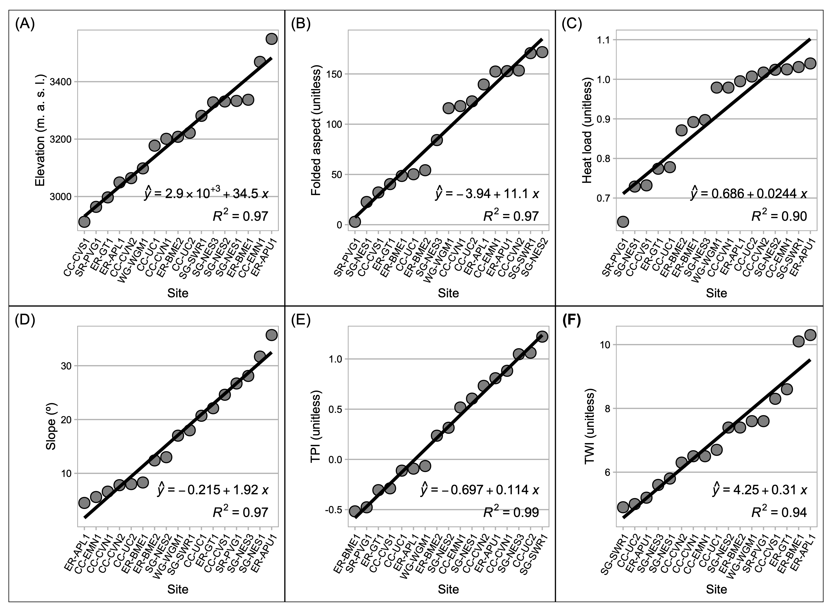

**Figure S2.** Raster images of abiotic explanatory variables. For Geology (P), the numeric scale [1-9] corresponds denotes the following lithologic groups: [1] Dakota Sandstone, [2] Mancos Shale, [3] Mesa Verde Formation (Sand/Silt/Coal), [4] Gothic Formation (Sand/Shale), [5] Maroon Formation (Red Sand/Mud/Conglomerate), [6] Glacial Drift, [7] Landslide Deposits, [8] Middle-Tertiary Granodioritic Laccoliths, [9] Wasatch Formation (Claystone-Shale).

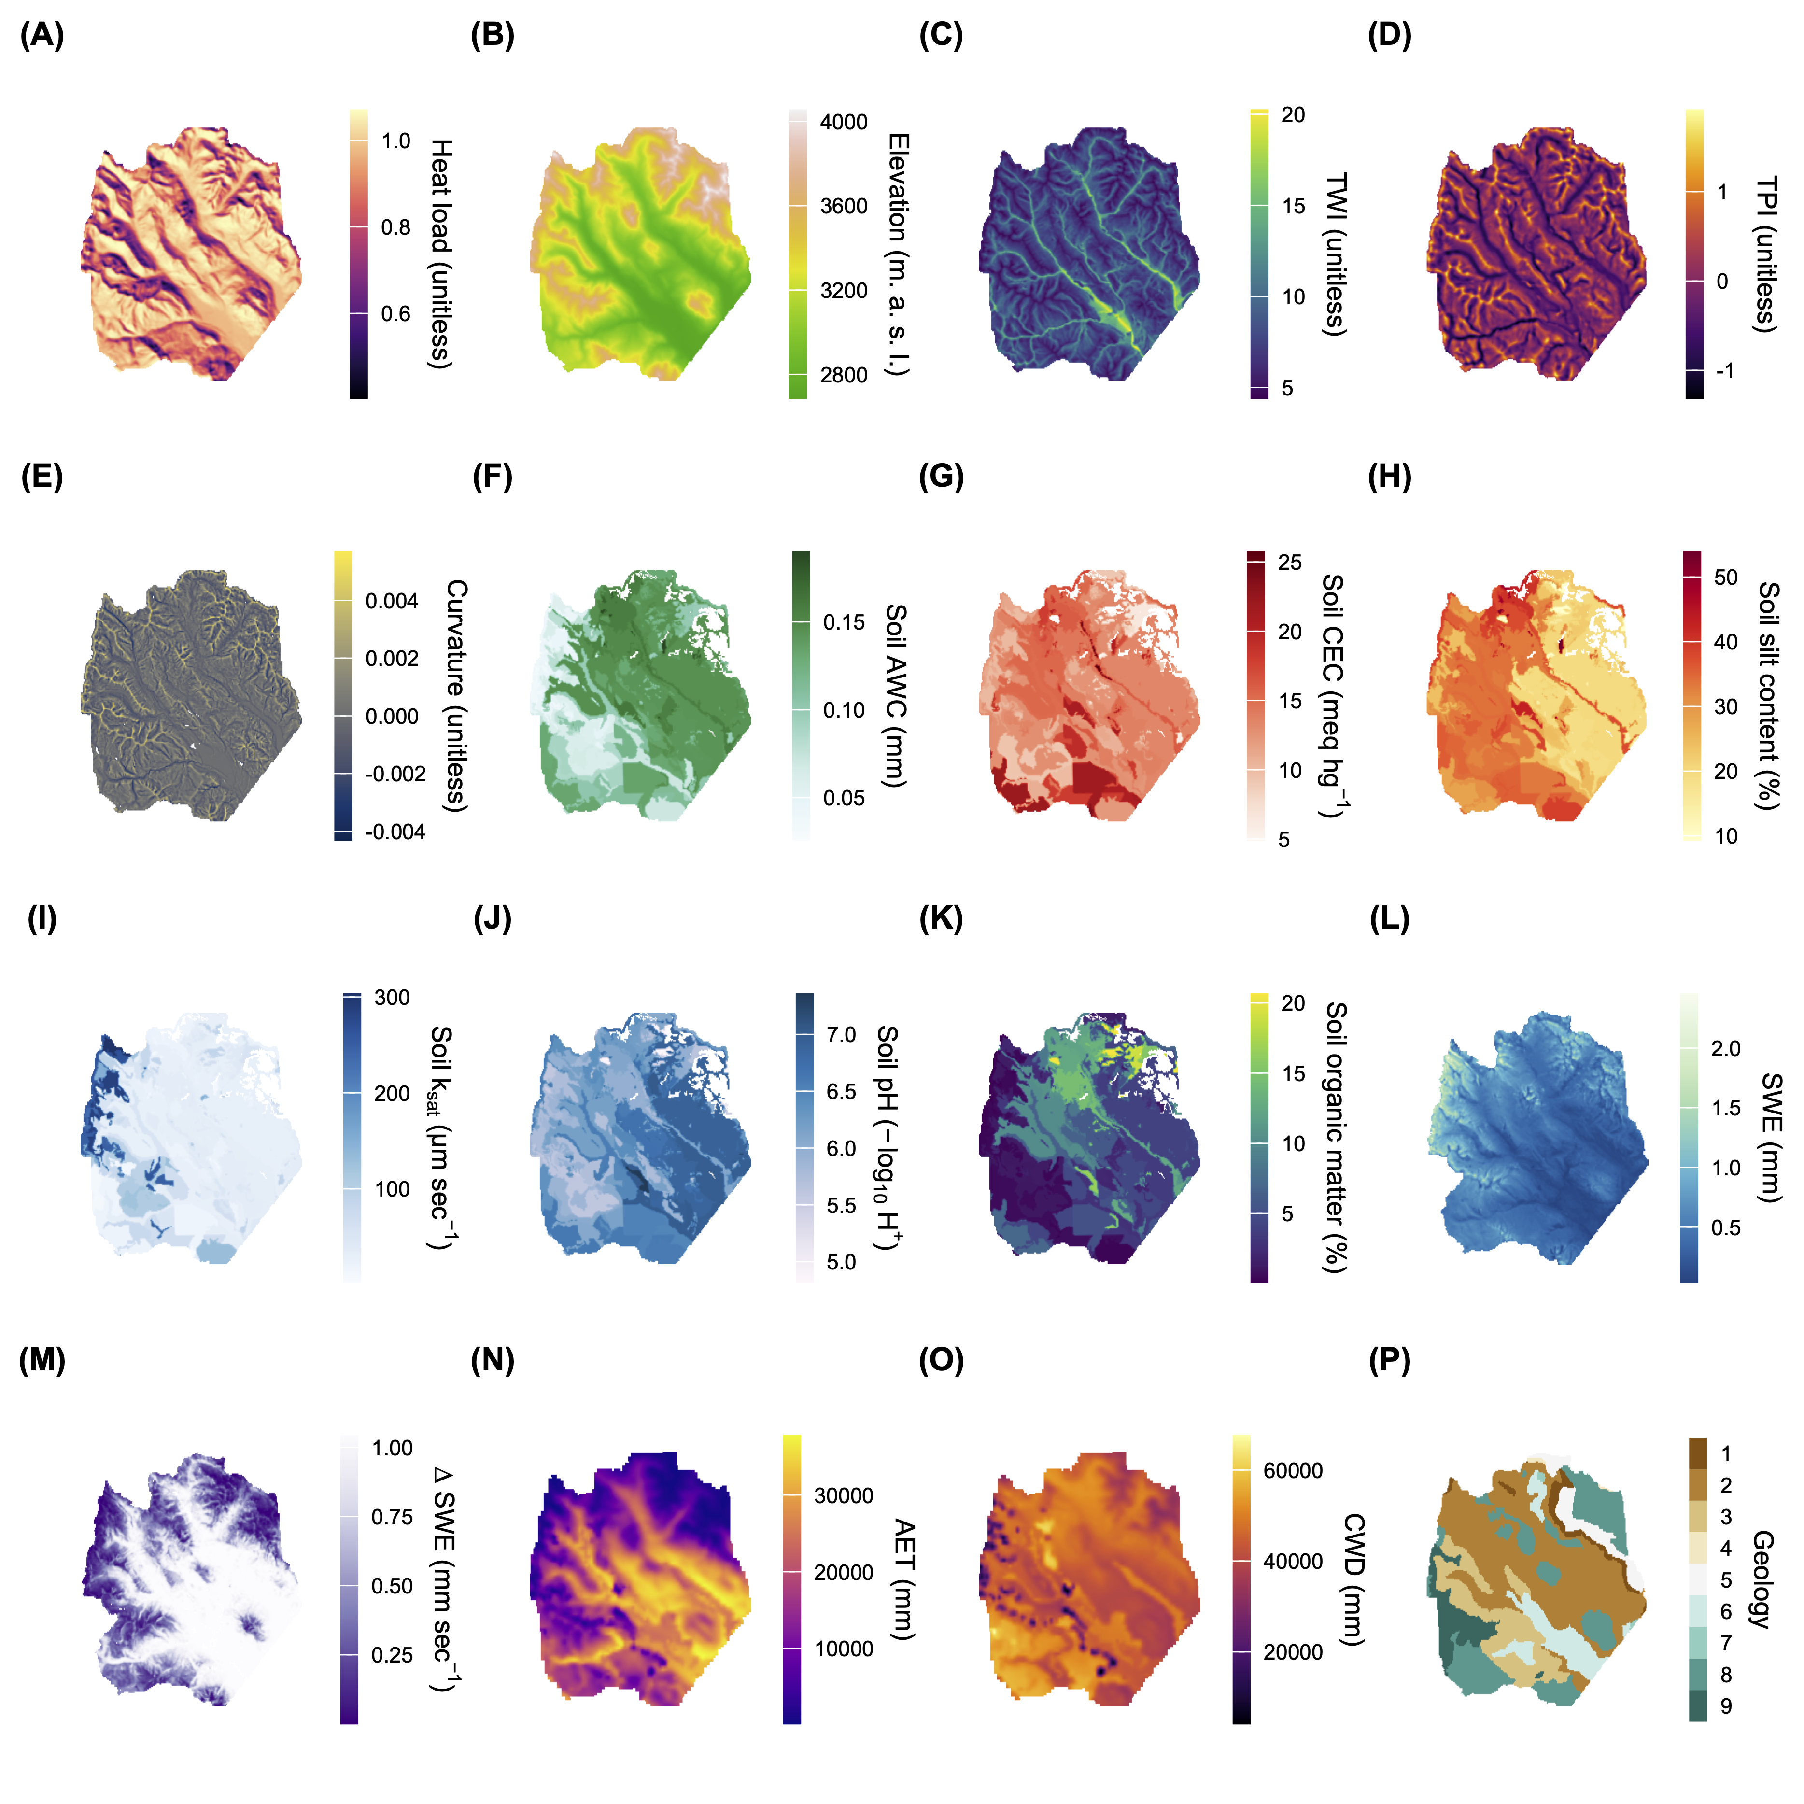

**Figure S3.** To estimate DBH for each LiDAR-detected tree object, we used a simple linear model fit to DBH and height measurements from field inventory. We first split the raw DBH values into 1 cm DBH bins and then fit the function to the mean height and DBH in each bin. For error estimation we implemented a training and testing scheme with 80%-20% splits over 100 randomization folds. At each step, we fit model parameters to the training set and predicted $\hat{DBH}$ on the testing set using the fitted model scaled by its $σ^{2}/$. We computed the relative error (%) and RMSE between field-measured DBH and allometry-estimated DBH in the testing set at each step and averaged them. For an additional validation step, we predicted DBH on 800 out-of-sample inventory measurements on conifer trees in plots within the watershed that were not otherwise used in this analysis. Training-testing RMSE was 5.0 cm, and bias was 3.3%. On the out-of-sample validation set, RMSE was 5.4 cm, and mean validation bias was +17.8%. Fig. S3 shows the agreement between field-observed and allometry-estimated DBH values on out-of-sample validation data. Shading is by the number of observations (trees), and the diagonal line is 1:1.

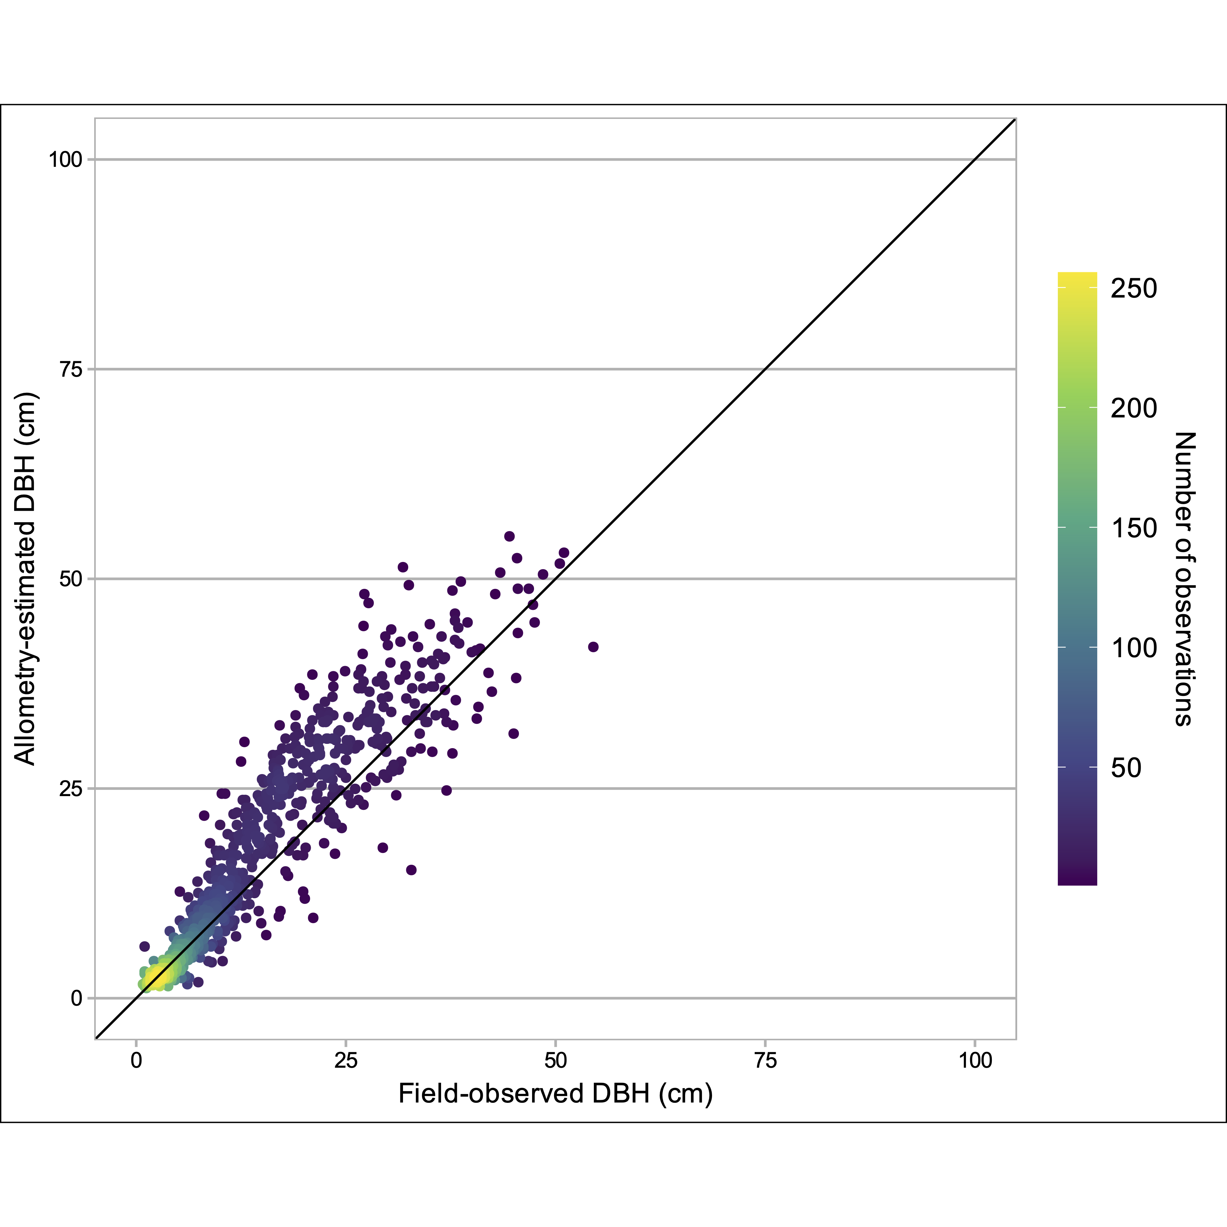

**Figure S4.** Partial-effects plots for all univariate explanatory variables in generalized additive models for each response (A-H).

